GIT essentials

**1.** **Installing Git**

<http://git-scm.com> – download and install

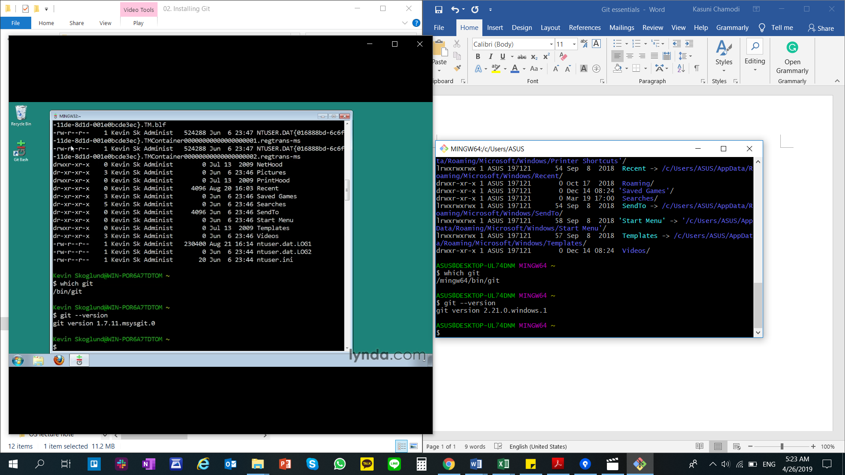

Type “dir” to get a list of available directories.

**2.** **Getting Started**

git init – initialize Git in a project

commit – git add . --> git commit -m “Initial commit”

view commit log – git log, git log --since=2019-04-07 (to get for a specific date)

**3. Making changes to files**

git status – reports difference between our working directory, staging index, repository

git commit -m “Add second file”

after making changes to a file – git add second_file.txt

view modifications done – git diff, git diff –staged

deleting – drag and drop to trash, git rm file_to_delete.txt

Move – git mv test.txt new.txt, git mv test.txt new_directory/new.txt

**4. Using Git with a Real Project**

git log – where head is pointed at. To find the last commit

**5. Undoing changes**

Undoing working directory changes - git checkout -- index.html

Upstaging files - git reset HEAD resources.html

Cat .get/HEAD, cat .git/refs/heads/master

Removing unstacked files – git clean -f

**6. Ignoring Files**

nano .gitignore (in windows use notepad)

**7. Navigating to commit tree**

git help ls-tree

git ls-tree HEAD

git ls-tree master

git ls-tree master assets/

git log –oneline

git log –oneline -5

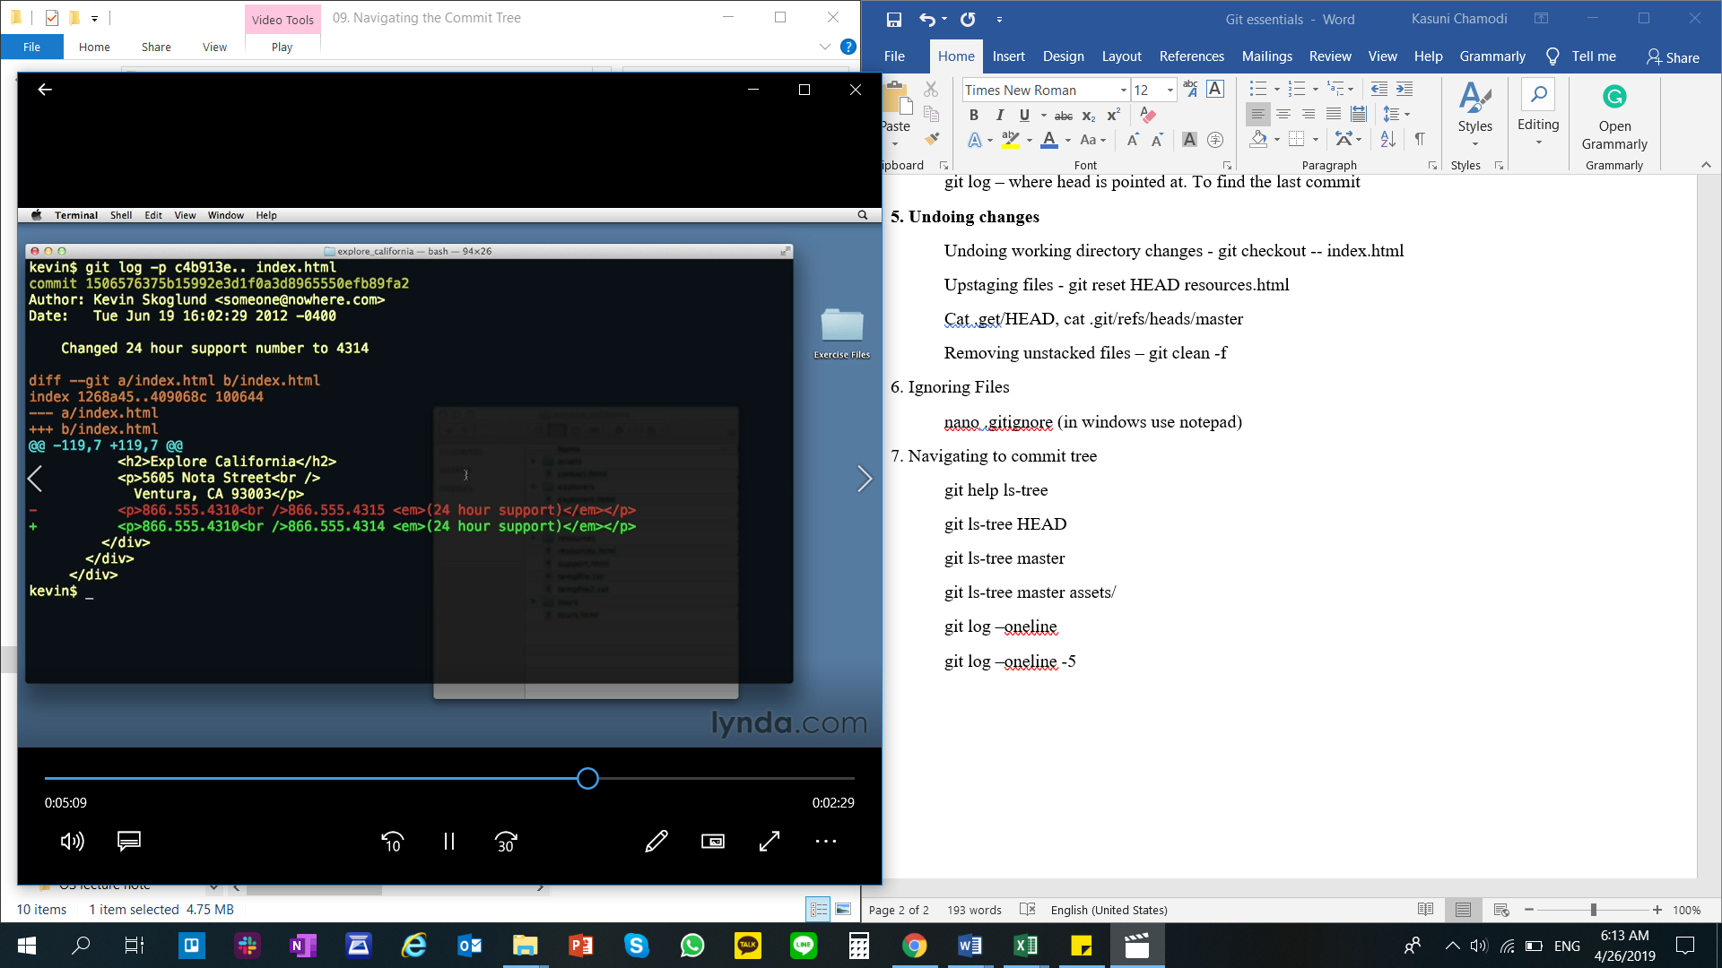

**8. Merging**

git merge seo_title

git log seo_title –oneline -3

git merge --no-ff branch

git merge –ff-only branch

git commit -am “replaces straight quotes with curly quotes”